Lab 26 - Configuring Hash Algorithm

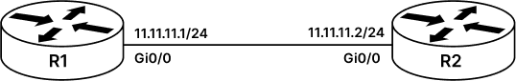

HASHING ALGORITHM LAB
Hashing Algorithm is a cryptographic function, where we take an arbitrary length of data and pass it through a hashing function to get a fixed output which is also known as fingerprint or message digest.
Hashing is a one-way function, where its infeasible to compute the original data with given fingerprint or message-digest. Hashing algorithm is most widely used in security as well networking, more popularly known as CRC in networking where it is used to check the integrity of an IP Packet.
However, CRC is not preferred when we talk security, we use more advance algorithm like MD5 (which is now not considered safe) however SHA1 and most popular SHA2 are the most advance hashing algorithms, which can also be seen today in cryptocurrency mining. i.e., BITCOIN most widely uses SHA 256 algorithm for mining and is considered the safest algorithm.
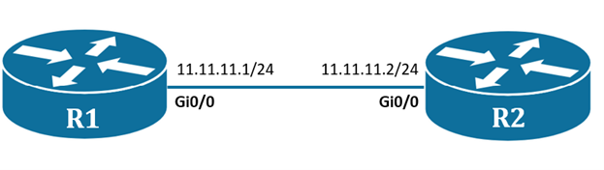
Task 1: Initial Configuration:
Step 1: To start with this lab we will first configure both the routers with relevant IP address.
R1#conf t
R1(config)#int gi0/0
R1(config-if)#ip add 11.11.11.1 255.255.255.0
R1(config-if)#no shutdown
R1(config-if)#int lo 1
R1(config-if)#ip address 100.0.0.1 255.255.255.0

----------------------------------------------------

R2#conf t
R2(config)#int gi0/0
R2(config-if)#ip add 11.11.11.2 255.255.255.0
R2(config-if)#no shutdown
Step 2: Configure RIPv2 routing protocol on R1 and R2 router.
R1#conf t
R1(config)#router RIP
R1(config-router)#version 2
R1(config-router)#network 11.0.0.0
R1(config-router)#network 100.0.0.0

-----------------------------------------------------

R2#conf t
R2(config)#router RIP
R2(config-router)#version 2
R2(config-router)#network 11.0.0.0
Step 3: Verify RIP routes and reachability between routers.
R2#show ip route
----Output Trimmed-----

11.0.0.0/8 is variably subnetted, 2 subnets, 2 masks
C 11.11.11.0/24 is directly connected, GigabitEthernet0/0
L 11.11.11.11/32 is directly connected, GigabitEthernet0/0
R 100.0.0.0/8 [120/1] via 11.11.11.1, 00:00:00, GigabitEthernet0/0

R2#ping 100.0.0.1
type escape sequence to abort.
Sending 5, 100-byte ICMP Echos to 100.0.0.1, timeout is 2 seconds:
!!!!!
Success rate is 100 percent (5/5), round-trip min/avg/max = 7/8/11 ms
R2#
Task 2: Configure Hashing Algorithm for RIPv2:
In the previous task, without any hashing algorithm, R1 was able to share routes with R2 router but here we cannot ensure the integrity of the received routes. To ensure integrity of routing updates, in this example, we will use MD5 hashing algorithm with a shared secret key ‘rstforum’ between routers. This will make Routers only accept verified routes using the MD5 hashing algorithm and secret key, thus ensuring integrity.
Step 1: Create a key named “rstforum” and attach it to the keychain named “RST”. This will be the key which will be later used with MD5 algorithm to generate fingerprint of the routing updates.
Note: Make sure the key-string matches on both the routers and note “space” is also considered as key so make sure to not leave any blank space after the key.
R1#conf t
R1(config)#key chain RST
R1(config-keychain)#key 1
R1(config-keychain-key)#key-string rstforum
R1(config-keychain-key)#exit
-------------------------------------------------
R2#conf t
R2(config)#key chain RST
R2(config-keychain)#key 1
R2(config-keychain-key)#key-string rstforum
R2(config-keychain-key)#exit
Step 2: Configure MD5 algorithm on the interface of both the routers to ensure integrity of routing updates.
R1#conf t
R1(config)#int gi0/0
R1(config-if)#ip rip authentication mode md5
R1(config-if)#ip rip authentication key-chain RST
--------------------------------------------------
R2#conf t
R2(config)#int gi0/0
R2(config-if)#ip rip authentication mode md5
R2(config-if)#ip rip authentication key-chain RST
Step 3: Now if RIP authentication is configured on both the routers, then we should start receiving routes. To verify we can check R2 routers routing table.
R2#show ip route
----Output Trimmed-----

11.0.0.0/8 is variably subnetted, 2 subnets, 2 masks
C 11.11.11.0/24 is directly connected, GigabitEthernet0/0
L 11.11.11.11/32 is directly connected, GigabitEthernet0/0
R 100.0.0.0/8 [120/1] via 11.11.11.1, 00:00:02, GigabitEthernet0/0

